**“DRAFT CLASS DISCUSSION GUIDE DOCUMENT”**

**LCUU 1202: ENVIRONMENT AND HUMAN ACTIVITIES**

**General overview of the unit**

**Credit Hours 3**

**Purpose**

The aim of this unit is to impart knowledge on different environmental concerns and to create a pro-environmental attitude and also aid the student know about the changes in biotic and abiotic componets of the environment. The unit will further equip the learners wih the anthropogenic impacts on the environment.

**Objectives of the unit**

* The course aims to equip the learners with knowledge of the effects of human activities on the environment and possible interventions on the challenges of sustainable development fostering shared knowledge in poverty reduction while protecting the environment.
* It also aims to impart knowledge on different environmental concerns and create a pro-environmental attitude that helps the student on issues about physiological changes in plants with the environment

**Expected outcomes:**

* To be able to discuss the impact of human development on education.
* Get the right knowledge on the importance of environmental studies.
* Get acquainted with the different types of pollution and their control measures and also on social issues and the environment.
* To participate in activities aimed at conserving the environment.
* Develop a sense of responsibility and urgency regarding environmental problems and their solution.
* Acquire analytical skills in assessing the quality of water, air and soil.

**Recommended books.**

1. 1.Uzzell D. 1999. Education of Environmental action in the community. New Roles and Relationships. Environmental Science, APH Publishing.
2. 2.Arvind Kumar, 2004. Environmental science. APH Publishing.

**Further Reading:**

1. Uzzell D. 1999. Evaluation of Environmental Action in the community. New roles and Relationships. Cambridge Journal of Education.
2. Korir Koech Michael, 1991. Education beyond the year 2000. Journal of East African Development. V21, PP30-52.

# Lecture 1 and 2

**Definition, scope and importance of environmental studies, Public awareness and**

**Natural Resources**

|  |
| --- |
| By the end of this lesson, learners should be able to:   1. Explain the causes and effects of deforestation 2. Explain the various classification of natural resources 3. Describe the ecological services obtained from forest ecosystems 4. Discuss the importance of environbmetal awareness |

**1.0 Introduction**

* The anthropological impacts on the physical environment stems from rapid population increase, agricultural activities, increased undustrilization, burning of fossil fuels and deforestation. These cactivities have resulted in exerbarated pollution of land, water and air resources, climate changes, acid rain and ocean acidification, ozone layer depletion as well as wearing away of the arrctic and antarctic glacrers.
* These environmenta issues constitute a serious threat not only to human survival, but to all living ecosystems (biodiversity) on the planet. Evidence can be drawn from the Holocene and Anthropoce epochs.
* It therefore means that public environmental awareness of these formidable consequences is of paramount importance in order to meet the challenges ahead and ensure a sustainable and an eco-friendly interrelationship to our souurondings.

The word environment was first introduced by Jacob Van Uerkal (1864-1944) and is derived from a French word (Environner) which means to encircle. The environment constitutes physical, biological and cultural elements. It is further noted that the scope of environment and human studies is a very wide topic and includes fields such as:-

* Ecological studies (the study of environment and the interrelationship betwe the biotic and abiotic components and their interdepedence)
* Natural resources conservation,
* Pollution causes and mitigation measures
* Human population explosion and its effects

It is important to note that human influence the environment through following:

1. Deforestation and land fragmentation
2. Reaslease of toxic pollutants in to the land, water and air
3. Poor traditional agricultural practices
4. Modern agricultrural activities

**1.2 Conceptual Basis for studying environment and human activities**

According to Elijah Akintunde (2017), this concept can be termed as a symbolic depiction of what is actual and living. The rapid depletion of natural resouces, global pollution and the associated impacts has meant human should find mitigation measures to ensure sustainable development. Currently, plastic pollution has spread from the deepest part of the ocean (Mariana trench) to the highest points of the plant, Mt. Everst. Furthermore, many marine waters including part of the Gulf of Mexico are already characterized as dead zones due to eutrophication.

Other issues affecting humanity include inappropriate agricultural practices, climate change, global warming, melting of the glaciers, sea level rise, loss of biodiversity, declining soil fertility, deforeststion, poor sanitation, inadequate clean water for all people, ozone layer depletion, waste menace (industrial/municipal/domestic), rapid population increse, industrilazation and urban growth among others. This means, awareness is urgently required as it is known to be a powerful tool towards creating meaniningful change in societies: hence the need for environmental studies. As noted by Elijah Akintunde (2017), knowledge results in awareness or change in attitude which is important in taking the correct mitigation action as illustrated below :-

|  |
| --- |
| Awareness  ACTION OR MITIGATION MEASURE  Knowledge |

* It is sad that human activity creates many ecological challenges that have great economic and intrinsic values (Dorward, A. R. 2014).
* To a large extend, the forest fires in California (USA), global warming and sea level rise, increased exticntion of biodiversity and the rapidly declining soil soil fertlity and productivity, the polluted air in New Delhi (India) and Beinjin (China), the floods and Tonadoes in USA and other parts of the world and emergence of many diseases can all be attributed to human activities.
* We can say that environmental destruction and human wellbeing is a related phenomena. Rememebr, although in a political contexed,  **Martin Luther King Jnr said, “ Only when it is dark can you see the stars**”. Now, with respect to environment, must humanity get to that point of ecosystem breakdown so as to take corrective and emitigation measures?.
* Indeed, it is a pity as indicated in the environmental Kuznets curve that human think of economic development first only to realize the same development has resulted in ecosystem damage before taking action. We need to wake up, *Yawa!!.*

**Note: A look at the Principles of Deep ecology vs Shallow ecology: The Naess view**

|  |
| --- |
| CF:   * According to Arnn Naess, only a “**deep**” transformation of modern society could prevent an ecological collapse |

As narrated by University of Oslo’s Prof. Arne Naess (1973) in the article *Shallow and the Deep, Long-Range Ecology Movement* and *Self-Realization: An Ecological Approach to Being in the World*, every being has an equal right to live and to blossom.

* The author puts it that understanding nature would give rise to a point of view that appreciates the value of biological diversity and understandings of dependent of the interrelationships in nature.
* Naess’s ecological philosophy is simple and emphasizes on self-realization of man’s narrow selves, that people must realize themselves as part of ecospheric whole.

As shown in the illustration below, we should view ourselves as part of the ecosystem.

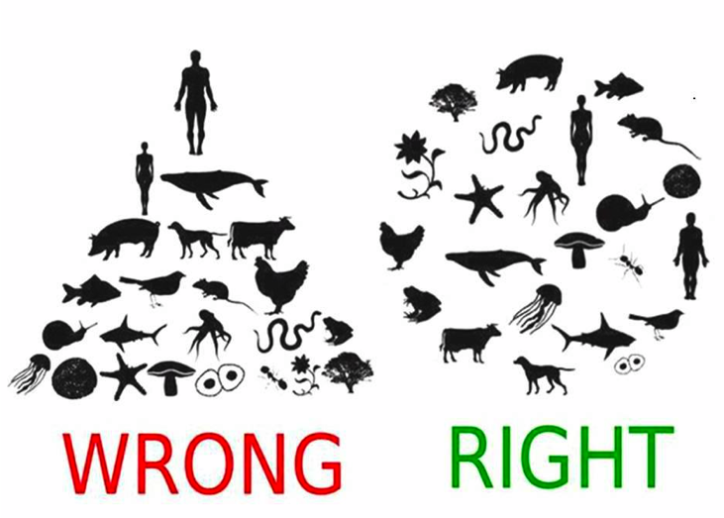

Naess view of Deep and Shallow Ecology (Adapted from other sources)

* Prof Naess explains that self-realization is if one does not know how the outcomes of one’s actions will affect other beings, one should not act.
* Deep ecology involves having respect for the global living as well as having the freedom to live and flourish.
* Deep Ecology differs from the concept of **shallow ecology** because it strives to **change the mind** of the person as a whole, rather than changing the mind of a consumer.
* Look at **sport hunting** and **habitat fragmentation**, human activities which have the potential of driving many organism towards extinction.
* Naess believes that **spiritual growth** will enhance our interactions with other creatures and further emphasizes deepening our identification with all life-forms, with the ecosystems, and with Gaia.
* Literally speaking, we must recognize that we are all interrelated and all forms of life contain intrinsic value. It is wise to point out that according to Naess, humans have not necessarily caused destruction of the earth **but rather our culture’s lack of concern towards our impact.**
  + - Separately, Weston (1992) in his article “*Enabling Environmental Practice”*, puts it that we must use a bottom-up technique.
      * + ***The author (Weston) argues that environmentalists should be in the business of presenting “an open ended challenges” to the status quo, “to create the social, psychological and phenomenological preconditions, the conceptual, experiential or even quite literal space, for a new or stronger environmental values to evolve***.
    - Note that environmental pragmatism (realism) does not seek to be anti-anthropocentric as well systemizing views of deep ecology. What Weston hopes to achieve is a **coevolution of practices** and institutions.
    - Essentially, here we see that rather than having one universal principle, a “**what works**” attitude would be more effective.

|  |
| --- |
| **Question**  (i). Give a criticism to Naess approach to deep ecology CAT 1 (4 Marks)  An approach to a suggested answer   * Although Naess’s idea is beautiful, it is not realistic because people do not suddenly gain an undying love for nature. Indeed, it takes a lifetime or a very significant event in one’s life in order to have such respect and adoration for the environment. * You see, one can be raised to respect and love animals, as well as respecting and enjoying the environment around him. Without this particular upbringing, one can instead feel very different. |

Generally, according to Weston, exposing people to environmental practices will create greater concern and raise consciousness, rather than telling people they should value the environment on a spiritual level. Thus if anything, Naess’s approach may turn people off from environmental ethics.

* Weston’s view, however, is an easier and quick approach to encompassing environmental ethics into people’s lives.
* Practices such as recycling programs at universities or creating nature outings for urban areas, will create the most change.

**Question**

(ii). Examine whether Weston’s approach realistic in solving environmental problems

|  |  |
| --- | --- |
|  | **Activity 1.1**   * What activities can humanity undertake to curb the current high rate of deforestation and land fragmentation. * Citing examples, examine the environmental changes faced in your county of residence.   ________________________________________________________  ________________________________________________________ |

**1.3 Permafrost and its effect on the environment**

Much like glaciers, permafrost is made up of soil, rocks, and frozen water that is frozen for more than two consecutive years and occurs mostly in high latitudes. In areas not overlain by ice, it exists beneath a layer of soil, rock or sediment, which freezes and thaws annually and is called the "active layer".

|  |
| --- |
| permafrost layers C:\Users\Guest\Desktop\index.jpg |

Pemafrost melting has the effect towards sea level rise, global warming besides other serious destructon of infrastructe (housing, roads, railway lines, gas pipes etc as depected in the picyures below

|  |
| --- |
| C:\Users\Guest\Desktop\index2.jpg C:\Users\Guest\Desktop\images3.jpg C:\Users\Guest\Desktop\images.jpg |

The release of carbon dioxide from permafrost melting is as illustrated below.

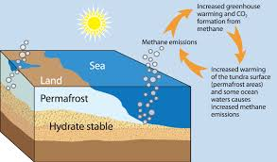

*Increased warming of the Tundra surface-permafrost area and Ocean waters cause methane emissions*

As shown above, warming seas are further accelarating the thawing of Permafrost further injecting more carbon dioxide into the atmosphere and therefore increasing the potential of global warming.

* Concomitantly, as global warming continuous progressively, the drowning some Islands is not inevitable. Acccording to scientists based at the **University of Plymouth**, Islands in the Maldives - where sandy or gravel islands sit on top of coral reef platforms - are among those that could be affected by **a global rise in sea levels**. It is predicted that the increased flooding caused by the changing global climate has been predicted to render such communities—where sandy or gravel Islands sit on top of coral reef platforms—uninhabitable within decades.
* University of Canterbury Don, Dr. Sutherland et al (2020) has further documented that melt water lakes that form at glacier margins (Proglacial lakes) cause ice to recede further much faster compared to glaciers that terminate on land. This accelerates glacier loss.
* Currently, we are staring at a sea level rise quickened by Greenland’s ice sheet record amount. Indeed, until the year 2000, Greenland ice sheet accumulated as much as it shed. However, at the moment, it shed a record 532 billion tonnes in 2019. Scientists project that if all of Greenland ice sheet were to melt, then it would lift the global oceans by seven (7) meters. This would effectively drown many low lying towns, cities, entire ecosystems and communities. Let’s hope it doesn’t.

If all of Greenland's ice sheet were to melt, it would lift global oceans by seven metres

|  |  |
| --- | --- |
| If all of Greenland's ice sheet were to melt, it would lift global oceans by seven metres | If all of Greenland's ice sheet were to melt, it would lift global oceans by seven metres. Human activities are to blane for this state of affairs. I hope you are part of the solution. |
| The photograph above depicts an entirely melted Greenland Ice sheet with water flowing and natural rock and bare soil exposed. If that happened in your life time, where would you take refuge | |

* Dr. Kim Jakob from Heidelberg University gives a warning that "The future melting of polar ice sheets and the associated rise in global sea level as a consequence of climate change will have a substantial impact on low-elevation coastal areas.

**Indeed,**

* **These warning is in resonance to Professor Paul Wilson of the University of Southampton's Ocean and Earth Science department and his team who state that the drastically increasing influence of humans on Earth's climate causes a melting of polar ice sheets and therefore a rise in global sea levels.**

**Russian Arctic heat records: Permafrost in the Arctic can thaw faster than presumed**

* Researchers have noted that the Russian northernn territories including Yakutia region which borders the Artic ocean has faced heat waves in recent years. As a result, villages in remore Tundra are battling serious wildfires.
* It is documentefd that fires at Verkhoyansk, were favoured by temperaratures as high as 380C leading to great loss and destrution of vegetation as shown below.

|  |  |
| --- | --- |
| Russia struggles with wildfires in its remote taiga every summer | Map of Russia showing fires in Sibera during the last 24 hours |
| Russia struggles with wildfires in its remote taiga every summer  The Russian Arctic set record temperatures in June 2020 that sparked abnormal tundra fires. Russia's head of weather service blamed climate change for the "fantastical" anomalies. | Map of Russia showing fires in Sibera during the last 24 hours  "It's an astonishing situation. Anticyclones happen more and more often and you can never predict where they are going to occur," he said |

On the geoplotical scene, we take note that the Russian president, **Vladimir Putin** has noted the benefits of **warmer temperatures** opening up **transportation routes** and **energy resources**, climate change is a huge hazard for the country's **infrastructure** built on permafrost.

The abnormal temperatures accelarated permafrost melting, thus further affecting natural landscapes and associated biodiversity. Take a look at the photo below:

|  |
| --- |
| A thermokarst pond in Siberia. Massive ground ice layers are visible under the vegetation. When they melt, the surface can collapse into depressions. According to the new study, such processes could dominate the landscape in the future. Credit: Jan Nitzbon.  Permafrost in the Arctic can thaw faster than presumed |

According to Jan Nitzbon et al. (2020), melting of ice in permafrost ground water table leads to processes of change in the landscape ­ thermokarst. This in turn may cause faster thawing of the permafrost.

* Research has shown that some of the coldest permafrost on Earth might be more vulnerable to thawing than previously thought. In the PERMANOR project led by the University of Oslo in Norway, scientists have investigated the so-called **thermokarst** processes which can significantly accelerate thawing of permafrost.

**Enhancement to global warming**

* It is reported that as air temperatures increase in high latitudes and in high mountain areas dominated by permafrost in the ground, the permafrost thaws thus releasing large amounts of greenhouse gases can be released to the atmosphere, which can potentially intensify global warming.
* Another consequence is that ice layers in the ground start to melt, so that the ground subsides and depressions with ponds and lakes form. This causes changes in landscape in what is referred to as, "thermokarst" which can further accelerate permafrost thawing in a positive feedback to global warming.
* **Prof.** Sebastian Westermann, (University of Oslo) further reported that Thermokarst not only affects permafrost regions in Siberia, but the same processes are taking place in Norway. Records indicate that within just a few years, new ponds have formed in many areas.
* Researchers have suggesteed that limiting global warming can help protect arctic ecosystems and landscapes from drastic changes due to thawing of ice-rich permafrost.

**Case study: Earthquakes and undergrand CO2 emmissions: the case of Italy.**

* We can also have carbon dixode being released via natural activities sush as earthquakes. Available data indicates that the amount of **CO2 dissolved in groundwater** is so large that, in some cases, **strong free CO2 emissions are associated with the water discharges**.
* Researchers have suggest that pressure created by increases in CO2 gas underground might be the factor setting off the earthquakes. They further suggest that if CO2 does set off some earthquakes, measuring it might be a way of predicting some of them. They also note that their findings highlight a source of carbon emissions into the atmosphere that needs to be added to global warming models.
* The illustrations shown below shed light on how the researchers affiliated with several institutions in Italy found a possible link between increases in CO2 emissions from groundwater and earthquake occurrences in Italy's Apennine Mountains.

|  |  |
| --- | --- |
| Increase in release of underground CO2 emissions in Italy tied to earthquakes | Increase in release of underground CO2 emissions in Italy tied to earthquakes |
| The emission in the picture shown above, which is located at **San Vittorino plain** (Rieti) about 30 km far from the epicenter of the April 2009 L’Aquila earthquake. Photo ►Courtesy of : Giovanni Chiodini – INGV. | In the Apennine mountains (Italy), the emission of CO2 of deep origin is well correlated with earthquakes occurrence during the last decade. In fact, during 2007-2019, the seismic events (including the destructive events of 2009 and 2016) were accompanied by evident peaks in the amount of deep CO2 dissolved and transported by the groundwaters in the area |

# The Arctic on fire: Siberian heat wave alarms scientists (2020)

* The Arctic has been reported to be feverish and on fire, at least parts of it are. And that's got scientists worried about what it means for the rest of the world. The thermometer hit a likely record of 38 degrees Celsius (100.4 degrees Fahrenheit) in the Russian Arctic town of Verkhoyansk on Saturday, a temperature that would be a fever for a person—but this is Siberia, known for being frozen.
* The catastrophic oil spill from a collapsed storage tank near the **Arctic city of Norilsk** was partly blamed on **melting permafrost**. In 2011, part of a residential building in **Yakutsk**, the **biggest city** in the **Sakha Republic**, **collapsed due to thawing and subsidence** of the ground.
* In August (2019), more than 4 million hectares of forests in Siberia were on fire, according to Greenpeace.
* As reported by Katey Walter Anthony, (University of Alaska Fairbanks), persistently warm weather, especially if coupled with wildfires, causes permafrost to thaw faster, which in turn exacerbates global warming by releasing large amounts of methane, a potent greenhouse gas that's 28 times stronger than carbon dioxide

The photo shown below gives the land surface temperature in the Siberia region of Russia. (In terms of climate change and global warming, this photo speaks volumes)

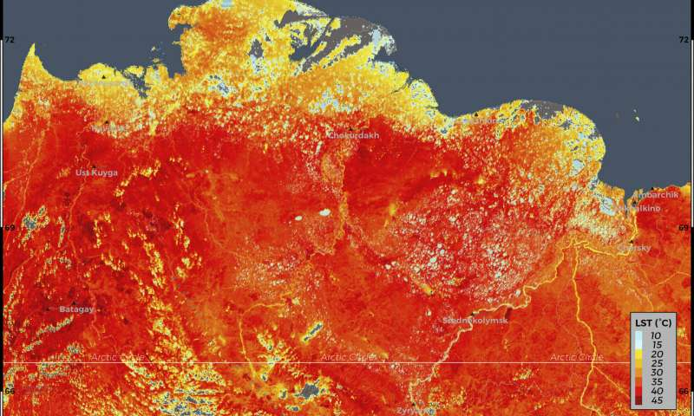

This photo taken on Friday, June 19, 2020 and provided by ECMWF Copernicus Climate Change Service shows the land surface temperature in the Siberia region of Russia. A record-breaking temperature of 38 degrees Celsius (100.4 degrees Fahrenheit) was registered in the Arctic town of Verkhoyansk on Saturday, June 20 in a prolonged heatwave that has alarmed scientists around the world. (ECMWF Copernicus Climate Change Service via AP)

* .

|  |
| --- |
| **Climate change puts hundreds of coastal airports at risk of flooding**   * Scientists have reported that even a modest sea level rise, triggered by increasing global temperatures, would place 100 airports below mean sea level by 2100. * As reported by Aaron N. Yesudian et al, (2020), a temperature rise of 20C, consistent with the Paris Agreement, would lead to 100 airports being below mean sea level and 364 airports at risk of flooding. To make it worse, if global mean temperature rise exceeds this then as many as 572 airports will be at risk by 2100. * Professor Dawson puts it that sea level rise poses a serious risk to global passenger and freight movements, with considerable cost of damage and disruption |

**..**

**Sea ice disappearance and the emergent of greener and browner landscale**

* A study of tundra shrubs shows that as sea ice disappears, the Arctic is becoming both greener and browner.

|  |  |
| --- | --- |
| As Sea Ice Disappears, A Greener and Browner Arctic Emerges | Changes on land are underway in the Arctic as sea ice is lost. Credit: Eric Post/UC Davis. Are we headed to an ice free Artic during summer? |
| According to University de Liege research team, the melting of the Greenland ice sheet could lead to a sea level rise of 18 centimeters by 2100 | |

* Sea ice decline is a powerful driver of warming and precipitation changes across the Arctic, while tundra shrubs are climatically sensitive proxies of environmental change. Yet the role sea ice dynamics play in driving vegetation changes on land is relatively understudied.
* Prof. Eric Post, a University of California Davis Polar Ecologist and Director of the Polar Forum states that Climate change is fundamentally altering the very character of the Arctic

**Note:**

|  |
| --- |
| **Melting Permafrost and discovery of well-preserved Ice Age woolly rhino found in Siberia** (*TUVAKA)*   * The melting of permafrost has opened a window for Paleontologists in higher latitudes. This is attested by discoveries of well-preserved Ice Age animals. In December 2020, a woolly rhino with many of its internal organs still intact was recovered from permafrost in Russia's extreme north whose initial dated was thought to be 20,000 to 50,000 years old. * It is noted that in recenent years, have seen major discoveries of mammoths, woolly rhinos, Ice Age foal, and cave lion cubs as the permafrost increasingly melts across vast areas of Siberia because of global warming has been |

|  |
| --- |
| **NOTE:**   * Make a research on how the last 12,000 years have shaped by humans to what it is today * You may refer to Larsen, Clark Spencer: The past 12,000 years of behavior, adaptation, population, and evolution shaped who we are today, 2023) |

|  |  |
| --- | --- |
|  | Activity 1.2   1. Discuss the human activity and the Atlantification of the Eastern Artic 2. Give a detailed account on how the last 12,000 years have shaped what human are today |

**NEXT CLASS**

**EMERGING ISSUES (REPORTED: 2022/2023)**

|  |
| --- |
| **Last 8 years warmest on record globally**   * The EU climate monitor has stated that shows that the last eight years were the warmest on record even with the cooling influence of a La Nina weather pattern since 2020, the European Union's climate monitoring service said Tuesday. * As reported by Marlowe Hood (2023), average temperatures across 2022 resulted into a cascade of unprecedented natural disasters which were indeed made more likely and deadly by climate change. It is stated that the year 2022 was actually the fifth warmest year since records began in the 19th century, according to the Copernicus Climate Change Service. * Elsewhere, Pakistan and northern India were scorched by a two-month spring heatwave with sustained temperatures well above 40 degrees Celsius (104 degrees Fahrenheit), * Then came the Pakistan floods that covered a third of the country, affecting 33 million people, leaving behind a whopping $30 billion (Ksh. 3 T) in damage and economic losses while in Europe, France, Britain, Spain and Italy set new average temperature records for 2022, * Heatwaves across many parts of the world were compounded by severe drought conditions. * In this regard, China and Western Europe reported negative impacts on agriculture, river transport and energy management related to weather conditions.   Global temperature anomalies in 2022 compared to the 1981-2010 average  Global temperature anomalies in 2022 compared to the 1981-2010 average.  In the polar regions, even the remote Vostok station deep in the interior of East Antarctica reached a relatively balmy minus 17.7C (0.14F), indeed, the warmest ever measured in its 65-year history.   * At the other end of the globe, Greenland experienced September temperatures 8C higher than average, accelerating ice sheet loss that has become a major contributor to sea level rise. * The atmospheric concentrations of the two main greenhouse gases that drive global warming, carbon dioxide (CO2) and methane (CH4) increased * CO2 levels rose to 417 parts per million, the highest level in **over two million years** while Methane rose to **1,894 parts per billion** surpassing the peak for over 800,000 years. * A world barely 1.2C above pre-industrial levels has already been buffeted by record heatwaves, droughts and temperatures, and is headed for a disastrous 2.8C above that benchmark. |

**1.4 Natural resources**

* Natural resources are resources that exist without actions of humankind. These are resources that occur in nature. They are materials or substances such as minerals, forests, water, and fertile land that occur in nature and can be used for economic gain.

**1.4.1 Classification of natural resources (NR)**

There are various methods used to categorize NR.

1. Source of origin
2. Stage of development
3. Renewability.

.

**(a).** **Classification according to the source of origin =**

* This has two classes (1) Biotic and (2). Abiotic. Biotic resources are obtained from the biosphere (living and organic materials) and include forests, animals, and materials obtained from them (fossil fuels, coal etc). Abiotic resources are those that come from non-living, non-organic and include land, fresh water, air, and heavy metals (gold, Copper, Silver, and Iron etc.

**(b). Classification according to Stage of Development. In this category, we have:**

**(i). Potential resources** = Resources that exist in a region and can be used in future. i.e. Undrilled petroleum in sedimentary rocks.

**(ii). Actual resources** =these are resources that have been surveyed and their quantity

and Quality is determined and are being used at present time.

**(iii). Reserve resources** = The part of actual resource which can be developed profitably in the future.

**(iv). Stock resources** = Resources that have been surveyed but cannot be used by

organisms due to lack of technology. E. g. good example is Hydrogen.

**(c.). Classification according to Renewability:**

* Here we have both Renewable and Non-renewable resources.

|  |  |
| --- | --- |
| **Non Renewable Energy Resources** | **Renewable Energy Resources** |
| (i). Fossil fuels   * Natural gas * Oil * Coal   (ii). Nuclear | * Solar * Wind * Hydro-power * Geothermal * Bio |

|  |  |
| --- | --- |
|  | **Activity 1.3**  (1)-Discuss the advantages and disadvantages of solar, wind, hydro  power and geo-thermal power sources  (2)-Examie-three-key-methods-ued-in-natural-reoure-claifiation |
|  |  |

**1.5 Forest resources**

Forest cover over 31% of the earths surface and support about 1.6 billion people for food, shelter, water, clothing and traditional medicine.

It is important to note that due to climate change, various countries of the world such as Kenya and Ethiopia have responded positively to mitigation measures by undertaking afforestatation and re-afforestation.

However, for countries, the forest percent cover has been on a steady decline. Forest provide a large ray of benefits to biotic ecosystems which include protective, productive and social satisfaction as shown below:-

|  |  |
| --- | --- |
| **ECOSYSTEM SERVICE** | |
| **Supporting services**   * Nutrient cycling * Soil formation * Primary productivity | **Provisioning services**   * Food, fodder, medicinal herbs * Fresh water * Fuel |
| **Regulating services**   * Climate regulation * Flood regulation * Disease regulation * Water purification |
| **Cultural services**   * Aesthetic * Spiritual * Educational * Recreational |

* Ecosystem services (as show above) are the benefits that people obtain from ecosystems. Ecosystem services are indispensable to the wellbeing of all people, everywhere in the world.
* They include provisioning, regulating, and cultural services that directly affect people, and supporting services needed to maintain the other services.
* From the availability of adequate food and water, to disease regulation of vectors, pests, and pathogens, human health and well-being depends on these services and conditions from the natural environment. Biodiversity underlies all ecosystem services.
* The continuing global warming may have adverse effects on many sensitive ecosystems.
* For example, researchers in China and the United States have warned that a warming climate could affect the stability of alpine grasslands in Asia's Tibetan Plateau, threatening the ability of farmers and herders to maintain the animals that are key to their existence, and potentially upsetting the ecology of an area in which important regional river systems originate.

|  |
| --- |
| **NOTE: West Virginia University:** **Biologists uncover forests' unexpected role in**  **climate change**   * Researchers based at the West Virginia University has shown that **trees around the world are consuming more carbon dioxide than previously reported**, making forests even more **important in regulating the Earth's atmosphere** and forever shift how we think about climate change. * As reported by Justin M. Mathias et al (2021**), increases in carbon dioxide** in the atmosphere over the past century have caused an **uptick** (Slight increase) in [trees](https://phys.org/tags/trees/)' [water](https://phys.org/tags/water/)-use efficiency, the ratio of carbon dioxide taken up by photosynthesis to the water lost by transpiration—the act of trees "breathing out" [water vapor](https://phys.org/tags/water+vapor/). * The researchers analyzed carbon and oxygen isotopes in tree rings from 1901 to 2015 from 36 tree species at 84 sites around the world and determined that that in 83% of cases, the main driver of trees' increased water efficiency was increased photosynthesis, meaning the trees processed more carbon dioxide. * The rise in [carbon dioxide](https://phys.org/tags/carbon+dioxide/) is the main factor in making trees use water more efficiently, the results also vary depending on temperature, precipitation and dryness of the atmosphere. |

It is noted that there is a **give and take** when it comes to the effects of global warming across the life forms on earth. In this regard:

* In 2018, the University of Minnesota (2018) researchers **warned that a warmer climate** will also be a drier climate with **adverse effects on forest growth**.
* The ongoing cimate change may have advere effets to many **competitive ecoytems**. For example, researchers in China and the United States have warned that **climate change could affect the stability of alpine grasslands in Asia's Tibetan Plateau**, thus threatening the **ability of farmers and herders to maintain their animals** which are key to their existence. Besides, this could potentially upset the ecologic setting of a region which is important origin of many useful rivers.
* Recently, research from **Martin-Luther University Halle-Wittenberg** has shown that from the Arctic to the tropics, **all plants** face similar challenges whether they are **small grasses, shrubs or huge trees**.
* Generally, although temperature and precipitation are important factors, **human activity** and thus **local land use** and the interaction of different plants at a given site have more impacts on the functional traits of plant communities (See Helge Bruelheide et al,. 2018). Global trait–environment relationships of plant communities, *Nature Ecology & Evolution*
* On other fields, **warmer climate** may mean a **boom for some animals** in some regions. For example, climate change leads to **longer growing seasons in the Arctic**. Research done by **Aarthus University** show that **predators like** **wolf spiders** (shown below) respond to the changing conditions and have been able to produce two clutches of offspring during the short Arctic summer. This has the potential to interupt the local ecosystem dynamics.

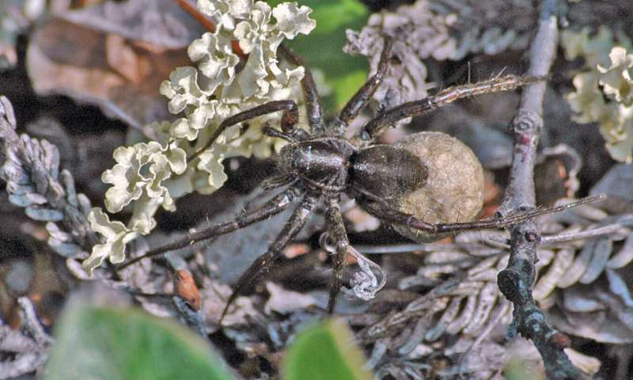

The wolf spider (*Pardosa glacialis*) is extremely common in the Arctic tundra. If, in future, it produces two generations of offspring during a season, these may have a significant effect on the prey on which the spider lives. Credit: Jörg U. Hammel

* Available litereature indicates that **Arctic spiders are at the top of the food chain** among invertebrates and are numerous on the Arctic tundra. They typically take several years to become adults, and only produce offspring.
* Researchers have previously reported how plants bloom earlier and earlier in the season. There are also signs that species move farther north and up into the mountains.

# Research case studies

|  |
| --- |
| Climate change threat to tropical plants :([University of New South Wales](http://www.unsw.edu.au/) )  * According to scientists based at the University of New South Walles (UNSW), **tropical plants closer to the equator are most at risk from climate change because it is expected to become too hot for many species to germinate in the next 50 years.** * As reported by Alexander T. Sentinella et al. (2020), **the closer a plant is to the equator, the more at risk it would be of exceeding its temperature ceiling by 2070.** * Prof. Sentinella adds that these plants could be more at risk because they are **near their upper limits.** So, even a small increase in temperature from climate change could push them over the edge," * It is predicted that by 2070, more than **20 percent of tropical plant species**, will face temperatures **above their upper limit**, which means they won't germinate, and so can't survive." * Worse still, the scientists argue that if those plants can survive it would be at **a reduced rate of germination and therefore, they might not be as successful**.. Dr. Martin Sullivan (University of Leeds and Manchester Metropolitan University) further reveals that up to a certain point of heating tropical forests are surprisingly **resistant to only a small temperature differences**.   **Tropical forests can handle the heat, up to a point (University of Leeds)**   * Another study carried out by reserachers from **University of Leeds** indicated that **tropical forests face an uncertain future under climate change**. * The team team reveal that tropical forests continue to store high levels of carbon under high temperatures, showing that in the long run these forests can handle heat up to an estimated threshold of 32 degrees Celsius in daytime temperature * The reseserachers conluded that tropical forests have long-term capacity to adapt to some climate change, in part because of their high biodiversity as  tree species better able to tolerate new climatic conditions grow well and replace less well-adapted species over the long-term   **Further reading:**   * Alexander T. Sentinella et al. Tropical plants do not have narrower temperature tolerances, but are more at risk from warming because they are close to their upper thermal limits, *Global Ecology and Biogeography* (2020). [DOI: 10.1111/geb.13117](http://dx.doi.org/10.1111/geb.13117) * M.J.P. Sullivan el al., "Long-term thermal sensitivity of Earth's tropical forests," *Science* (2020). [science.sciencemag.org/cgi/doi … 1126/science.aaw7578](https://science.sciencemag.org/cgi/doi/10.1126/science.aaw7578) |

**Forest resources and deforestation**

One particular problem caused by **over-exploitation** of natural resources is **deforestation**, which occurs when forest areas are cleared and the trees are not replanted or allowed to regrow. In East Africa especially Kenya and Ethiopia, **clearing land for agriculture** to meet the food needs of the growing population and the demand for fuel and construction materials has resulted in a steady loss of forest area. The figure below shows the land area loss due to deforestation

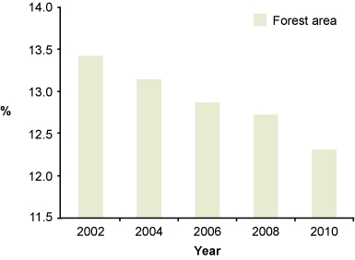

**Proportion of land area in Ethiopia covered by forest (%) from 2002 to 2010**. (Adapted *from MoFED, 2012a)*

**Effects of loss of forests (deforestation)**

Loss of forest has several undesirable consequences. Forests are home to many different types of trees, as well as other plants, and a wide range of **animals from insects to birds and mammals.**

1). The conversion of forests to agriculture greatly reduces **biodiversity**, which is a

measure of the variety of living organisms (all life forms). **Biodiversity is important**

for humans because we use other living organisms to provide several essentials:

* *Food:* we use plants and animals such as fish, goats, wheat, rice and maize as sources of food.
* *Medicines:* many traditional medicines are made from plants and animals and new medicines are developed from them.
* *Ecological services:* living organisms, especially plants and micro-organisms, play an important role in processes that maintain our lives and environment such as providing **oxygen**, **cleaning the air**, **purifying water**, **breaking down wastes** and controlling erosion. (Cf = **Broadly, we can have provisioning, regulating, cultural and supportive services from forest ecosystems**)

2). **Deforestation** is a significant contributory cause of **soil erosion**. Once the trees and

undergrowth are removed, the underlying ground is exposed. Without the

intercepting effect of the vegetation and the tree roots binding the soil together,

the soil is more likely to be washed away when it rains.

3). **Loss of forests** also has a significant impact on **water supply**. Tree roots reach deep

into the soil and create spaces between the particles which increases soil

permeability, allowing rainwater to soak in and replenish groundwater. Note that

**Permeability** means the ease with which water moves through soil or rock.

* Generally, f**orest cover 31%** of the earth’s surface. It is estimated that 1.6 billion people rely on the benefits forests offer including **food, fresh water, clothing, traditional medicine and shelter.** A forest is a large area dominated by trees and forest resource means the various types of vegetation normally growing and the associated harvested products including but not limited to brush, grass, logs, saplings, seedlings, trees and slashing. Forest resources are useful in maintaining **ecological balance**, providing **fire wood, providing raw materials to many industries**, providing protection to wild **animals** and to conserve the soils. Natural forests are those which have spontaneously generated themselves on the location and which consist of naturally immigrant tree species and strains. **Natural forests can be more or less influenced by culture,** e.g. by logging or regeneration techniques, but the forests must not have been subject to regeneration by sowing or planting".
* Forests provide an array of benefits to human societies above and beyond their pivotal roles as habitat and environmental regulators in natural ecosystems. Indeed, because trees **absorb carbon dioxide** and turn it into wood, where the carbon stays bound up for hundreds or even thousands of years, living forests are an important part of the earth's **climate system**. Growing trees soak up CO2 from the atmosphere and store it in their trunks, roots, leaves, and forest soils

# Reserach:

# Bedrock type under forests greatly affects tree growth, species, carbon storage

* According to Warren P. Reed et al, (2020), a forest's ability to store carbon depends significantly on the bedrock beneath. The substratum greatly has great effects on the forest productivity, composition and associated physical characteristics of rocks.
* This can have implications on forest management systems., because forests growing on shale bedrock  have been shown to  store 25% more live, aboveground carbon and grow faster, taking up about 55% more carbon each year than forests growing on sandstone bedrock.
* Further, as noted by Prof. Margot Kaye, forests underlain by shale provide more ecosystem services such as carbon uptake and biodiversity.
* Looking at this more critically, as forests grow and respond to warming, shifts in precipitation and invasive species invasive, managers stand to benefit by incorporating lithological influences and considerations on forest composition and productivity.
* For example, conserving forests growing on shale with higher species diversity will likely lead to forests that are resilient to stressors and can grow more vigorously.
* We can therefore see why we should target forests growing over shale for conservation and carbon sequestration.
* On the other hand, or in contrast, forests growing over sandstone may be better suited for wildlife habitat management or recreation.

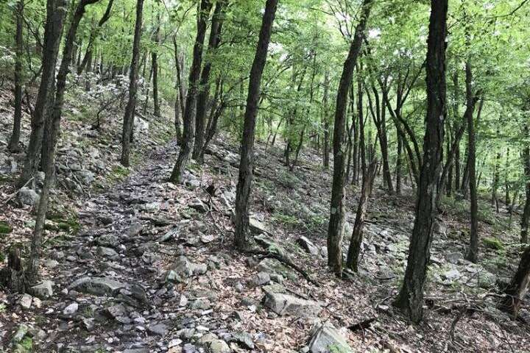

*Above: A typical stand of chestnut oaks growing on top of the Tuscarora Quartzite formation in Rothrock State Forest. Forests growing above sandstone bedrock like this have smaller trees and less diversity of tree species*

Pennsyvania State University researchers stress that this concept of geologic influences on forest growth will be especially valuable can be valuable to both soft and hardwood lumber establishments.

Warren P. Reed et al (2020) further notes that since sequestering carbon in forests is one of the many nature-based solutions we have to combat global climate change, this ecosystem service has the potential to continue to gain traction and eventually greater market value.

**1.6 Causes and impacts of deforestation**

Deforestation is a process through which forests are permanently destroyed while converting land available for other economic uses. It is noted that on the other hand, forest degradation is the “*Forest degradation is the long-term reduction in the overall capacity of a forest ecosystem to provide benefits, such as biodiversity conservation, carbon storage, wood products due to humanic alterations.  Forest degradation leads to a decrease in tree cover and the number of species (flora and fauna) in the forest.*

**Causes of deforestation**

* Agricultural activities
* Logging: Urbanization
* Mining
* Industrialization, dams
* Desertification of land
* Forest fires

As noted by Dr. Duke, (2016/2017), **mangroves**, like coral reefs, are **vulnerable to changes in climate and extreme weather events**. This has been witnessned by the large-scale **dieback of mangroves** in Australia due to **2015/16 drought** and high temperatures as shown below.

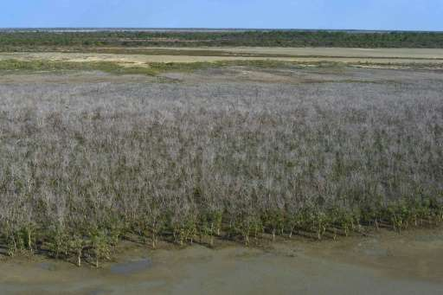

A huge swathe of Australian mangroves die of thirst

**Impacts of deforestation**

* Reduced and /or loss of biodiversity:
* Climate imbalance
* Disruption of Water cycle:
* Disruption of livelihoods
* Increased global warming
* Increased Soil erosion:
* Floods:
* Reduced Life quality

**The above effects can be broken down into:**

**(i). Short term environmental effects**

* Increased soil erosion
* Disruption of water cycles.

**(ii). Long term environmental effects.**

* Reduced biodiversity
* Climate change.

**(iii). Economic effects**

* Influence on livelihoods
* Migration and social conflicts
* Loss of medicinal plant banks
* Increased food insecurity
* Flooding and loss of lives. /homes.

*The mitigation for this lies in the governments, corporations, communities and individuals to work together. Mahatma Gandhi said adviced that “****You may never know what results come from your action, but if you do nothing, there will never be result.”***

**Next class december 2022**

**Energy resources**

The use of renewable or non-renewable resources is a critical factor when considering energy resources. Fossil fuels have been the main energy source for global industrialisation, but because they are non-renewable, the quantity is ultimately limited and their use is not sustainable over the long term.

A problem also arises because burning of fossil fuels is known to be the main cause of climate change. However, thank GOD, we have several renewable alternatives to fossil fuels. These include **wood ,water** (cf = Grand Ethiopian Renaissance Dam, currently under construction), **solar power**, using photovoltaic cells that convert the sun’s energy into electricity and **wind**.

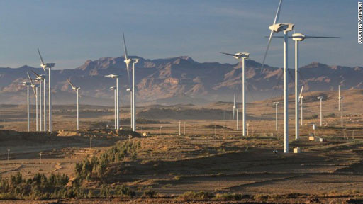

***Windfarm at Ashegoda, Tigray Region. (In Kenya, such technologies are already in place as in Ngong hill – Nairobi, Turkana and Lamu Counties.***

**1.7 The Biotic pyramid**

* The biotic pyramid (illustrated below) is the relationship between members of the biosphere and the physical environment that they occupy.

|  |
| --- |
| Description: https://encrypted-tbn0.gstatic.com/images?q=tbn:ANd9GcQ8hACNolryU0TyZDUANJhPevM48z2PS89GzR7mVvp8YxbeJJ4sHgDescription: Image result for the biotic pyramid |

Adapted-from-other-ouree

Generally, the the base of the pyramid consists of the abiotic factors of geology (Lithosphere) and climate (Atmosphere). The shape of the population represents the concentration of mass or population in each level.

**Law-of-the-biosphere**

From the-relatiohipofthe-ioti-level,-five-law-of-the-iophere-ae-derived-a-follow:-

* The-law of prodution
* The law of-adaptation
* The-law of fertility
* The-law of succesion
* The law of cotrol

The base of the pyramid consists of the abiotic factors of geology (Lithosphere) and climate (Atmosphere. The shape of the population represents the concentration of mass or population in each level.

**The laws of the Biosphere.**

From the relationship of the biotic pyramid levels, five (5) laws of Biosphere ca be derived.

**(i). The law of production.**

This law states that production must always equal or exceed consumption. Each level has a carrying capacity and that capacity is exceeded, the levels above will reduce themselves by starvation and disease.

**(ii). The Law of Adaptation.**

This was introduced by Sir Charles Darwin as follows:

More organisms are born than can survive.

**The offspring bring with them the good and bad traits of their parents.**

Those with good traits survive the competition.

The survivors pass the advantages for survival to their offspring.

**The albino traits in herbivores makes it easy to be spotted by carnivores and are rapidly wiped out**.

**(iii). The law of fertility.**

This law states that nutrients must recycle to keep the environmental system functioning. For example, the plant roots absorb water and soil nutrients and via photosynthesis, leaf /litter biomass is produced. The leaves fall, die and get decomposed and release nutrients back to the soil and hence maintaining the soil fertility.

**(iv). The law of succession.**

This illustrates the orderly sequence of plant species that will occupy a newly established landform. E. g. The Kilauea volcanic eruption has given a good orderly sequence of vegetative growth following deposition of lava flow. After a volcano eruption, the first plants form the primary succession. If there are no more volcanic eruptions, the landform stabilizes and may become a tropical rain forest at the higher, wetter windward elevations. On the contrary, the leeward side develops shrubby desert vegetation at the lower coastal elevations. .

**(v). The law of control.**

Many species of animals have control mechanisms that govern their members. For example, the Snowy Owl will change the clutch size if food reserves in their territory decline and will lay 4-5 eggs when their main source of food (Brown lemmings). During adequate food supply, they can lay between 12 to 15 eggs.

Similarly, the *Pomarine jaeger* (Arctic nesting bird) expands its territory size if the food supply is low but will always lay two eggs.

We see that the population size of any species is dictated or defined by the carrying capacity.ui

**NEXT CLASS**

**Ecosystem stability**

**Stability has two components:**

**(i). Resistance –** this refers to the ability of an ecosystem to continue to function without change when stressed even after disturbance.

**(ii). Resilience** – According to (**Odum, 1989 and Seyboldet et. al., 1999)** this can be explained as the ability of an ecosystem to recover after disturbance.

**Factors affecting ecosystem stability:**

* Disturbance frequency and intensity (how often and what kind of tillage)
* Species diversity , interactions and life history
* Trophic complexity , redundancy (how many [populations](javascript:void(null);) perform each function) and food web structure
* Rate of nutrient or energy flux

**1.8 Disturbance and stability**

* As reported by (Gleissman, 1998), we can learn a lot from ecological studies: As expected, **agricultural and agroecosystems tend to have reduced structural and functional diversity,** as such, they ha/ve less resilience than natural systems. **Humans are an integral part of agroecosystems** bcause the expected outputs must be to similar inputs. What would you of say of biodiversity after forest fragmentation ???!!!!; Indeed as it is today, most parts of the **Congo (DRC), Amazon** (Latin America), **Miombo woodlands** (Tanzania) fast lossing their glamour in terms of biodiversity. And in Kenya, **Mau forest complex**, the **Aberdares, Mathews range, Mt Kenya** have notbeen spared either.
* Furthermore, in Kenya’s South Eastern Region, even the remote forest hills of **Endau** and-**Nuu-hill** forests in Kitui county are already in great danger. Similarly, The **Iveti** forest In Machakos County has almost lost its biodiversity. The **Mbooni** forests in Makueni are currently in a unhealthy state.
* Along the Kenyan coast, **mangrove ecosystems** especially in Kwale and Kilifi Counties were critialy degraded during the 1970,s through the 1980’s. It took great effort by many stakeholders to try and correct the evil. In **Ngomeni region** (Kilifi), clearance of mangroes for salt mining activities led to crteation of “*wet-desert’s*.

The **Intermediate Disturbance Hypothesis**

The illustration below can be been used to explain the ecosystem stability. The Hypothesis states that the highest levels of diversity are supported at intermediate levels of disturbance (frequency or intensity)..

* Ecosystems experiencing intermediate levels of disturbance, will have the highest diversity, the greatest redundancy, and, therefore, the greatest stability.

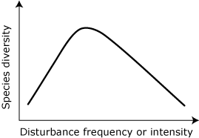



You have come to the end of lecture one. In this lecture you have learnt the following:

1. Human is to take the blame for environmental degradation
2. Environmental awreness can can be an important tood in mitigation of degraded ecosystems.
3. Ecosystems such as forest biomes are of paramount importance to humanity

Now take a break and reflect on some of the issues we have discussed today. After your break, answer the following questions:



1. Discuss the causes and effects of deforestation

_________________________________________________________________________________________________________________________________________________________________________________________________________________________________

1. Explain four key ecosystem services realized from forest in Kenya.

____________________________________________________________________________________________________________________________________________________________________________________________________________________________________________________________________________________________________________

3. Examine how human activity affects the biotic pyramid

4. With respect to a named mangrove ecosystem in Kenya, explain and illustrate the

Intermediate Disturbance Hypothesis

______________________________________________________________________________________________________________________________________________________________________________________________________________________________

|  |  |
| --- | --- |
|  | 1. Dorward, A. R. 2014. Livelisystems: a conceptual framework integrating social, ecosystem, development, and evolutionary theory. *Ecology and Society* **19**(2): 44  Akintunde, Elijah. (2017) Theories and concepts for Human Behaviour in Environmental Preservation. Journal of Environmtal Science and Public Healt. 01.120-133.10.26502/jesph.96120012. |

**EVALUATION**

We appreciate your evaluation of the course. Please give us comments in the following areas and forward them to the Dean of the School (email) at your earliest convenience.

**Circle the most appropriate response**

Clarity of information Very clear Clear Not clear

Sequence of content Very good Good Poor

Standard of material Very good Good Poor

Questions in assessed assignment Very helpful Helpful Not helpful

Time required covering content Adequate No comment Inadequate

Suggestions you would like to make concerning this course:

----------------------------------------------------------------------------------------------------------------------------------------------------------------------------------------------------------------------------------

**3.0 Lecture 3: Water resources**

|  |  |
| --- | --- |
|  | By the end of this topic, learners should : -   1. Be able to understant the sources and uses of water om the planet 2. Eexplain effects of overutilizatiopn of surface and ground water 3. Understant why human should not drain wetlands |

**.**

**3.1 Sources of water.**

**(i). Surface water**

* This includes waters inrivers, lakes and wetlands and is naturally replenished by precipitation. Losses of this water include discharge to oceans through the process of evaporation abd evapotranspiration.

**(ii). Under river water:**

* This water is found / and or passes water passes through rocks and sediments that underlie the river and its floodplain (hyporheic zone) and is usually a dynamic interface between surface water and ground water from aquifers.

**(iii). Ground water**

* This is generally ground fresh water which is located in the subsurface pore space of soil and rocks or flowing within aquifers below the water table.

**(iv). Frozen water**

* As the name suggests, this is solid wateroften considered as surface water and its use has only been for research.

**(v). Desalination**

* Generally, desalination is an artificial process by which saline sea water is converted to fresh water. It serves as an alternative water supply that can reduce pressure on traditional water sources besides increasing the amount of available water.

**Types of dessalination**

* Distillation and then condensation.
* Reverse osmosis where pressure is applied to force fresh water pass through a salt impermeable membrane.

**3.2 Uses of water**

Asw shown in the figure below, human water use can be classified into three main categoriesdomestic uses: -

* Domestic use: drinking, washing and cooking
* Agricultural use: principally for irrigation
* Industrial uses: manufacturing processes as well as energy generation

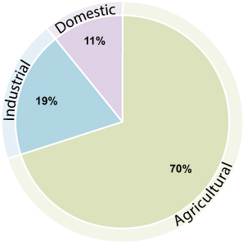

*Global water withdrawal by sector. (Adapted from FAO, 2012)*

We note that since the end of WW11, urban centers and cities have grown as people continue with the trend of rural – urban migration. This has had the effect of increasing pressure on the existing water resources in various areas of the world.

**3.3 Other uses of water**

**(**i**). Recreation:**

(ii). **Environmental water use:**

* This forms a very small but although the percentage is growing year after year as peoples affluence increases. Examples include watering of natural or artificial wetlands, artificial lakes intended to create wildlife habitat, critical fish ladders, water releases from reservoirs timed to help fish spawn, or to restore more natural flow regime.

|  |  |
| --- | --- |
|  | **Activity 1.4**   1. What activities should human undertake to ensure a sustainable water use in Kenya? 2. Read and understant the uses of water in East Africa with special reference to Kenya. |

**.**

**Sustainable water supply**

* This means having adequate supplies, in both quality and quantity, to meet the current and future needs of people and of the environment.

**3.4 Global water availability**

* As reported by the United Nations , 2014), many countries of the world are already experiencing water stress or scarcity. In this regard, water stressed countries are those which have less than 1700 m3 of water per person per year for all purposes are while  **Water scarce** countries have less than 1000 m3 of water per person per year. Below is a figure illustrating global fresh water availability.

**[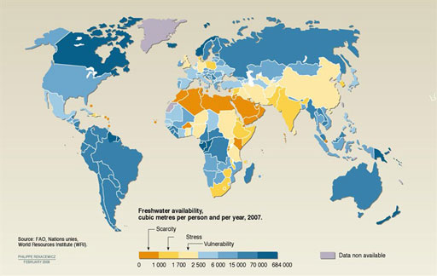](http://www.open.edu/openlearncreate/mod/oucontent/view.php?id=79926&amp;printable=1&extra=thumbnail_idm2950288)**

***Global freshwater availability in cubic metres (m3) per person per year (2007). (Note that although calculated ‘per person’, these figures apply to all uses of water not just personal use.) (WWAP, 2012)***

* We should understant that according to Harrison Tasof (University of California - Santa Barbara**,** the world's supply of fresh water may be more limited than previously thought (See Grant Ferguson et al, 2018 - Competition for shrinking window of low salinity groundwater, *Environmental Research Letters* (2018). DOI:10.1088/1748-93226)
* In November, 16th, 2018, Cape Town, in South Africa which nearly suffered serious water shortages could beat future droughts by cutting down most of the non-native trees including pine, acacia and eucalyptus. Are Eucalyptus contributing to a similar show in Kenya.

**3.5 Case Study: Effects of water use on Lake Alemaya in Ethiopia**

A look at lake **Alemaya Ethiopian Highlands** serves as an example of **fast disappering water sources**. Thye lake **was 8m deep in the mid 1980’s** and covered over **4.72km2.** According to UNEP, BY 2005, the water surface has drastically reduced as shown in thye illustration below

**[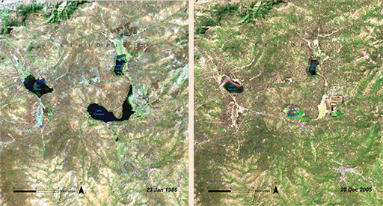](http://www.open.edu/openlearncreate/mod/oucontent/view.php?id=79926&amp;printable=1&extra=thumbnail_idm2939200)**

*Loss of water from Lake Alemaya, between 1986 and 2005. (Courtesy of UNEP, n.d. 2)*

In Kenya, we have witnessed similar trends as observed in **Lake Olbolosat** (Nyandarua), **Lake Kenyatta (Lamu**), Lake **Turkana (Turkana)** among many other wetlands and water bodies.

**Causes of water decline**

* Human use … Agriculture … (irrigation)
* Deforestation
* Global Warming thus,
* Increasing the rate of evaporation from.
* Note that in Australia, logging must now be stoped in Melbourne’s laggest Thomson water supply catchment which stores over 60% of the required water in this region. What lesson can new learn in our case – Kenya. Discuss.

**Utilization of surface and ground water**

**(i). Consumptive use:** In such uses, water is completely utilized and cannot be reused.

Examples include : domestic, industrial and irrigation

**(ii). Non-consumptive use:** In this case, water is not completely utilized and is reused

As seen in Hydropower plants.

**3.6. consequences of over-utilization of surface & ground water**

1. Decrease in ground water.
2. Building construction activities have led to sealing of permeable soil zone thus reducing water soil percolation.
3. In cases where groundwater withdrawal rate is higher than recharge rate, sediments in aquifers get compacted resulting in sinking of overlaying land surface in what is refered to as land subsidence
4. Disturbance of the water equilibrium and lowering of the water table as well as effects on speed and direction of water flow.

**Note:**

* + - Recently (2016/2017), **Colorado State University Professor Kurt Fausch** and **Jeff Falke** reported that for more than half a century of groundwater pumping from the aquifer has led to long segments of **rivers drying up and the collapse of large-stream fishes.** The cause of this is by farmers in the **Great Plains** of **Nebraska, Colorado, Kansas** and the **panhandle of Texas** who produce about one-sixth of the world's grain, using water from the High Plains Aquifer—**often known as the Ogallala Aquifer**—the single greatest source of groundwater in North America.

**Sustainable water management.**

* The current growing pressure on water resources is alarming! – look at the exponential population growth, the economic growth, effects of climate change, pollution just to mention a few – all these have major impacts on our social, economic, and environmental well-being. It is not a secrete that most important aquifers are being over-pumped, causing widespread declines in groundwater levels, now what next? …. Its simple, Protecting our water and natural environments through better water management is crucial in adapting to changing demography, resource use and climatic regimes.

**Task: Read and understant water issues involved in: -**

1. Donana wetland in Spain (Europe)
2. Looming crisis of the much decreased fresh-water supply to Egypt's Nile delta
3. Acid rain:why is it more of a problem today than it was two Centuries ago?
4. The chemistry: gasses reaction with rain ater:
5. Coal combustion:.
6. Gas powered vehicles
7. Industrial agriculture

|  |  |
| --- | --- |
|  | **Activity 1.5**   1. To read and understant the looming crisis with regard tom the construction of the Great Reinaisance Dam of Ethiopia along the Blue Nie. 2. To read and understant the causes and effects of acid rain. |

[**Wetlands**](https://phys.org/tags/wetlands/)**: A valuable resource, and not just wastelands**.

* We should eductate our people to change the perception that swamps are wastelands and should be drained.
* It is noted that most countries of the world have ratified the **Ramsar Convention** including major polluters such nas the United States of America, China and India. Indeed, since coming into force in 1975 more than 2,300 sites of international importance have been designated .
* Wet lands form critical habit for many organisms
* Wetlands play a crucial role in climate change mitigation
* Mitigation of disaters (floods, etc)

|  |  |
| --- | --- |
|  | You have come to the end of lecture one. In this lecture you have learnt the following:   1. Sources and uses of water 2. Globalo water availability and examples of case studies 3. `Consequences of overutilization of surface and ground water |

Now that you have successfully learned about water resources, answer the follwing questions.



1. Name five sources and five uses of water
2. Explain the importance of wetlands
3. Examine in detail the status of water availabil;ity in Kenya

|  |  |
| --- | --- |
|  | **Further reading** |

**EVALUATION**

We appreciate your evaluation of the course. Please give us comments in the following areas and forward them to the Dean of the School (email) at your earliest convenience.

**Circle the most appropriate response**

Clarity of information Very clear Clear Not clear

Sequence of content Very good Good Poor

Standard of material Very good Good Poor

Questions in assessed assignment Very helpful Helpful Not helpful

Time required covering content Adequate No comment Inadequate

Suggestions you would like to make concerning this course:

------------------------------------------------------------------------------------------------------------------------------------------------------------------------------------------------------------------------------------------------------------------------------------------------------------------------------------------------------------------------------------

**Lecture 4:**

**4.0. Food resources**

**Food Sources, World Food Problems and Food Security,**

|  |  |
| --- | --- |
|  | **`**By the end of this lesson, learners should be able to:-   1. Explain the term food reources/ 2. Understant the impacts of agricutureothe-eviromet |

**4.1 Introduction to food resources**

* As indicated in Encyclopedia Britannica *(2017-05-25),*food is any substance

eaten (consumed) to provide nutritional support for an organism. Generally, food resouces are usually of plant or animal origin, and contains essential nutrients, , such as proteins, vitamins, carbohydrates, minerals and fats.

* We can have three major sources of food for humans are: - the **croplands 76%),** the **rangelands (17%)** and **fisheries (7%).**
* It is noted that croplands provide the bulk amount of food for human, with rangelands providuce milk and meat from livestock.
* Today, the available area for **grazing on grasslands or pastures is rapidly declining** and in many occasions, the **herds exceed the carrying capacities** which lead to consequences such as land degradation, soil erosion and loss of useful species. The aquatic sector provides fish, an important source of animal protein in the Earth, particularly in coastal areas and many parts of the Asia continent. It is sad that as people become more affluent, they incline to consume more cheese, milk, meat and eggs.

**Impacts of excessive agriculture.**

Agriculture is the major source of food for humans and dates back to as long as man exists from hunter gatherer to civip0lized agriculture.

**4.1.2 Effects of modern agricultural activities include:**

* Impacts of **High Yielding Varieties** (HYV).This encourages monoculture and thus any attack by pathogens can devastate the crop significantly.
* Fertilizer related problems: NPK are essential macronutrients and heavily used to boost production and can therefore cause micro-nutrient imbalance**. Nitrates pollute** ground water and can cause the **Blue baby Syndrome (*Methemoglobinemia*)**  in addition to **Eutrophication**. .

**Babies showing blue baby syndrone**

 

**Healthy babies**

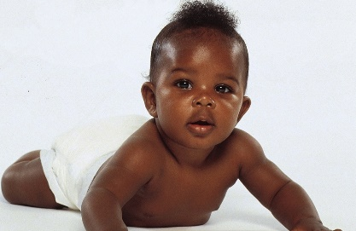

* Pesticide related issues: death of non target organisms, and **biological magnification** (i. e. the increasing concentration of a substance, such as a toxic chemical, in the tissues of organisms at successively higher levels in a food chain) = //*the increasing concentration of toxic substances within each successive link in the food chain*//. Biological magnification occurs because many pesticides are non-biodegradable and keep on accumulating in the food chain.
* Water logging; Inadequate drainage causes high water column, inadequate aeration,
* Salinity issues: Water evaporates and leaves behind white crust of salts which has a higher electrical conductivity and high sodium percentage, etc.

**Effects of traditional agriculture.**

* Deforeststation due to slash and burn practices
* Clearing of forests for new farming areas.
* Depletion of nutrients.

|  |
| --- |
| **Note**   * *As reported by WWF, Farmed areas – both on land and in the water – provide important habitats for many wild plants and animals.* * *When farming operations are sustainably managed, they can help preserve and restore critical habitats, protect watersheds, and improve soil health and water quality.* * *But when practiced without care, farming presents the greatest threat to species and ecosystems.* |

**How does agriculture affect the environment?**

* Negative environmental impacts from unsustainable farming practices include: Land conversion & habitat loss. Wasteful water consumption. Soil erosion and degradation.

**How does agriculture affect the soil?**

* Farming: Soil erosion and degradation. Erosion commonly occurs following conversion of natural vegetation to agricultural land – carrying away fertile soil as well as fertilizers, pesticides and other agrochemicals. Intensive agriculture is causing serious soil erosion in many parts of the works. (Look at areas of the Gulf of California, Mexico) .

**General class or personnal task.**

1. What are agricultural activities that take place in your home county?
2. What are the opportunities for improvement in the activities mentioned in above in section (a)?

**4.1.3 The Effects of Human Traditional and Modern Agricultural activities on the**

**Environment**

## Description: http://www.goldiesroom.org/Multimedia/Bio_Images/22%20Ecology/14%20Human%20Impact%20on%20the%20Environment.jpg

*Adapted from other sources*

## It is important to that as regards the types of food resources, there are 2 kinds of food production are as follows: -

## The industrialized agriculture.

## The traditional agriculture.

Generally, World food problems include : -

* + - Natural disasters (Climate change, floods, droughts,
    - Poverty
    - Global food prices
    - Uncontrolled population.
    - Foreign companies
    - Undernourishment

**Impacts of Over-grazing**

* Overgrazing, soil erosion, land degradation (reduced humus content and removal of vegetal cover, trampling, reduced organic recycling, loss of useful plant species, floods, reduction in plant diversity
* ***Energy resources, renewable and non-renewable energy sources and their impact on the environment, This section is dwelt with in chapter 2 above.***

### Note: Effect of global warming on protein in key crops

* As reported by Smith M. R. (2017) and Danielle E. Medek et, al. 2017), Rising carbon dioxide levels from global warming will drastically reduce the amount of protein in staple crops like rice and wheat, leaving vulnerable populations at risk of growth stunting and early death. This will put at least 150 million people at risk if protein deficiency by 2050. Furthermore, according to Murray A. Rudd (2015), continued use and abuse of ocean environments is having a detrimental effect on marine habitats across the globe. The ocean is dynamic and complex, often with long time lags before we can reverse the consequences of human activities, so building our scientific understanding is essential, if future generations are to inherit healthy oceans.
* Similarly, on the aquatic systems, Oysters are reported to be at great risk from the changing climate. The Institute of Physics has reported that climate change effect on coastal ecosystems is very likely to lead to accelarated mortality of adult Oysters populations in the next two decades. This will be a great blow to manu lovers of the highly priced and nutrient rich sea food – (See Yoann Thomas et al. Oysters as sentinels of climate variability and climate change in coastal ecosystems, *Environmental Research Letters* (2018). [DOI: 10.1088/1748-9326/aae254](http://dx.doi.org/10.1088/1748-9326/aae254))

|  |  |
| --- | --- |
|  | **Activity 1.6**   1. Examine the status of food security in Kenya 2. Discuss the effects of climate change on food crop production among tropical countries |

**Componenets of food security**

Food security in a population means that **all people, at all times, have sufficient access to food to meet their dietary needs for a productive and healthy life**. The four components of food security:

**(i). Availability: Basically, this means** having sufficient food for all people at all times in

appropriate quantities.

* At all times to have adequate world food supplies of basic foodstuffs to sustain a steady expansion of food consumption and to offset fluctuations in production and prices” (United Nations. 1975.

**(ii). Access:** Physical and economic acess to food for all people at all times :  (having adequate

income or other resources to access food),

* Acess to culturally acceptable food , which is produced and obtained in ways that do not compromise peoples diginity, self respect or human rights: (Look at Food Aid and the conditions it may come with).

**(iii). Utilization/consumption:**  This mmeans having adequate dietary intake and the ability

to absorb and use nutrients in the body.

**(iv). Stability:** The issues of supplies and acess.

* According to CCAFS (2014), Food insecurity can be transitory with short term shocks the result of a bad season, a change in employment status, conflict or a rise in food prices. When prices rise, it is the poor who are most at risk because they spend a much higher portion of their income on food. Poor people in Malawi spend nearly 78% of their income on food, while poor in the US, spend just 21%.
* **Agency** : The policies and processes that enable the achievement of food security.

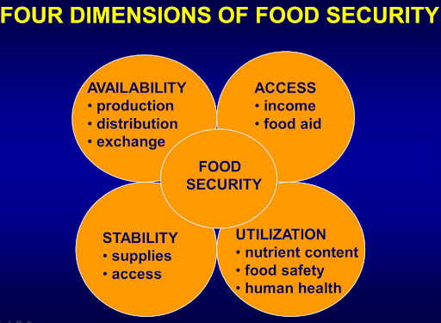 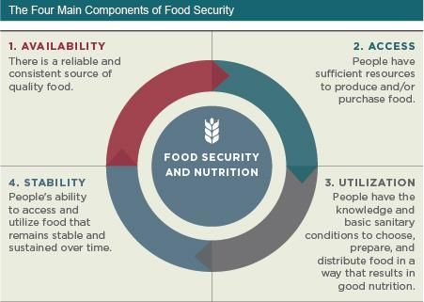

**..**

**Note: Food Insecurity:**

* According to FAO, food insecurity can be defined as “A situation that exists when people lack secure access to sufficient amounts of safe and nutritious food for normal growth and development and an active and healthy life.”

**NOTE: Food waste: The biggest loss could be what you choose to put in your mouth –**

[According to the Weizmann Institute of Science](http://www.weizmann.ac.il/) in ISRAEL (2018), about a third of the food produced for human consumption is estimated to be lost or wasted globally. It is furthet noted that the biggest waste, may be associated to dietary choices that result in the decadent use of environmental resources.

* In this regard, scientists have used the term "**opportunity food loss,"** which is coined from the the nconcept of economics "opportunity cost" concept, which refers to the cost of choosing a particular alternative over better options.
* For example, as observed in the USA alone, and from the use of same land resources, the opportunity food loss is estimated to be able to feed over 350 million people – a number bigger vthan the couintries population , with the same land resources.
* Furthermore, Dr. Alon Shepon analysis has shown that favoring a plant-based diet can potentially yield more food than eliminating all the conventionally defined causes of food loss,"

It has been noted that plant-based replacements could produce two- to 20-fold more protein per acre. Agricultural experts and Scientists proved this by comparing the resources required to produce five major categories of animal-based food **(beef, pork, dairy, poultry and eggs**) with the resources required to grow edible crops of similar nutritional value in terms of protein, calorie and micronutrients.

|  |
| --- |
| **Note:** Research study: University of Illinois at Urbana-Champaign **(** 2018)  The 'bread basket' of the tropics? In other studies, the tropics have been explored as a key “bread basket of the world”. Indeed, it is noted that only in thelate-1990s the tropicswere observed and /or arose to emerge possible regions for growing major world food grains especially particularly soybean. Currently, in central Brazil, farmers have been successful in in their respective farm enterprises largely due to introduction of new tropical succession farming system which allows two Lrge crops (maize and soybean) to be grown annually. |

|  |  |
| --- | --- |
|  | **Activity 1.7**   1. Citing reasons for success or failure, explain the succession farming systems which are undertaken in your home localities |

**4.1.4 Agriculture and environment**

There is no doubt that agriculture plays a crucial role to humanity as it provides essential **food crops** and as a source of **income**. It contributes to many countries **Gross Domestic Product** (GDP). For example, looking at Kenya and Ethiopia, approximately 80% of the labour force is located in the agricultural sector, thus greatly ncontributing to the **livelihoods of the majority of people**. On the nother side however, agriculture has serious negative impacts on our environment which include pollution, **loss of biodiversity**, global warming and **climate change, soil erosion**, sedimentation and excessssive diverssion and use of water for irrigation.

Poor agricultural practices as observed in steep areas contributed significantly in **soil erosion**. For example, Tamene and Vlek, (2008) reported that in Ethiopia, more than 1.5 billion tons of soil are lost from the Ethiopian highlands annually). The lost leads to sedimentation – thus **silting up rivers and lakes. In many occassions, thermal pollution is the final output.**  Soil erosion further causes a **decline in soil fertility** which in turn **reduces agricultural productivity causing hunger and famine**. Appropriate mitigation meassures include use of appropriate and suitable agricultural practices, such as the use of terracesand diversion ditches in steep slopes is (see figure below).

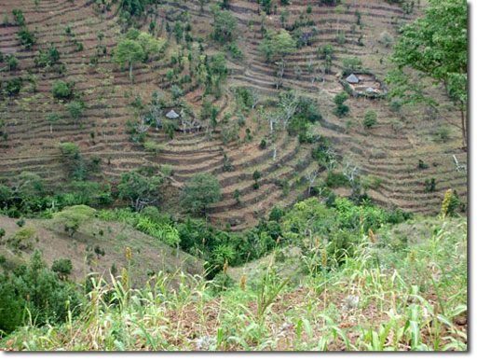

*Good agricultural practices such as building terraces on sloping land helps to conserve soil. (Adapted from other sources)*

It is important to note that agriculture plays a role in causing **climate change** through the release of **greenhouse gases** into the atmosphere. For example, fertilisers added to the soil release **nitrous oxide** and livestock production releases **methane from the digestion** process in cattle and the **decomposition of manure**. The increased use of **fossil fuels to power agricultural machinaries** and **burning trees** to clear agricultural land both release **carbon dioxide**

|  |  |
| --- | --- |
|  | You have come to the end of this lesson. In this lecture you have learnt the following:   1. Effects of agricultuiral activites on the environment 2. Issues of food losses 3. `Agriculture and the environment |

**..**

**EVALUATION**

We appreciate your evaluation of the course. Please give us comments in the following areas and forward them to the Dean of the School (email) at your earliest convenience.

**Circle the most appropriate response**

Clarity of information Very clear Clear Not clear

Sequence of content Very good Good Poor

Standard of material Very good Good Poor

Questions in assessed assignment Very helpful Helpful Not helpful

Time required covering content Adequate No comment Inadequate

Suggestions you would like to make concerning this course:

-------------------------------------------------------------------------------------------------------------------------------------------------------------------------------------------------------------------------------------------------------------------------------------------------------------------------------------------------------------------------------------------------------------------------------------------------------------------------------------------------------------------------------------------------------------------------------------

**5.0 Land resources**

* Simply said, land resources means the available resources from the land and include arable lands, underground water, minerals, etc. Application of technolopgical advances such as GPS and GIS have been used in the study of these resources.
* First, it is worth to note that Land is the foundation for all life-sustaining processes on the planet and in economics;land comprises all naturally occurring resources whose supply is inherently fixed.Such as mineral deposits, forests, fish stocks, atmospheric quality

**4.2.1 Land degradation**

This is a process in which the value of the biophysical environment is affected by a combination of human-induced processes acting upon the land. Factors that have contributed to land degradation include:

* Soil erosion.
* Loss of soil fertility.
* Soil structure change.
* Salinization.
* Industrialization > deforestation and urbanization
* Soil pollution.
* Desertification.
* Deforestation: Loss of vegetation cover.
* Overgrazing: introduced herbivores such as rabbits and goats

Looking at Ngwata region where the Famous Lukenya University is located, selective logging of Acacia tree species and other hard woods for charcoal and timber products is one of the main causes of vegetation change. The area is now dominated by secondary vegetation comprised of ***Commiphora Africa*, *Albizia anthelmintica*** among other low value trees.

**4.2.3 Desertification and land use Planning**

* Accordingt to the U.N. Convention to Combat Desertification (UNCCD) Land degradation in the ASAL regions is the reduction or loss of the biological or economic productivity of Drylands.
* It involves the persistent degradation of Dryland ecosystems by climatic variations and human activities.. According to S.B. Adamo, K.A. Crews-Meye (2006), the process of desertification is complex, involving interaction among many factors, both environmental and anthropogenic

**4.2.3.1 Land use Planning**

Land use: This means the use of land that includes how humans are using land for agriculture,, residential, commercial, industrial developments etc. and as population and human increase, land becomes an increasingly scarce resource, calling for land-use planning

* Land use planning is the rational and judicious approach of allocating available land resources to different and using activities and for different functions consistent with the overall development agenda /goal of a particular area, county, country, region etc.
* Land Use Planning is a powerful tool for used in controlloing and designing ways in which human use land and other natural resources and its role is critically crucial especially in the long term (Hugh McClintock, 2002).
* Looking at Kenya, the total land size is 82,646 aq km of which 97% is land while 2.2% is water. It is in record that approximately 20% of the land is has medium to high potential agricultural use.
* Note we can have five main land use types. These include, main different types of land use: **residential, agricultural, recreation**, **transportation**, **commercial. Other uses include Institutional, forests, pastures/grasslands, mining, marshes, infrastructure etc.** Land-use planning is important to mitigate the negative effects of land use and to enhance the efficient use of resources with minimal impact on future generations.
* For example, Land Use Planning is essential role in guiding land use and land cover changes (LULCC) over time and has the potential to minimize soil quality decline, and can enhance climate change resilience (Claudia et al., 2020).
* According to Nha (2017), land-use planning (LUP) is estimated as an ideal tool to allocate and reallocate land resources for development and sustainable development purposes. Indeed, in many parts of the world, land Use Planning approaches have been greatly improved over the past decades due to the advancement of geographic information technology systems. such as GIS-based models.
* Given the numerous environmental and social issues that have been brought on by rapid urbanization in the past decades worldwide, Kai Cao (2018) pits it that sustainable land use planning is critical for steering new developments towards a sustainable society.
* **sustainable land management** (SLM) as “the **use** of **land** resources, including soils, water, animals and plants, for the production of goods to meet changing human needs, while simultaneously ensuring the long-term productive potential of these resources and the maintenance of their environmental ..

**Factors that contribute to Urban Sprawl**

* Lifestyle
* Economic
* Planning and Policy

**Problems associate with unplanned growth.**

* Transportation
* Air pollution
* Loss of sense of community
* Death of a central city
* Higher infrastructure costs
* Loss of open space
* Loss of farmland
* Water pollution issues
* Wetland misuse

**4.3 Global Land decay (dedradation) and displacement of people**

* It is sad that land decay caused by factors such as pollution as observed in several cities Jakarta, Indonesia among others is undermining the well-being of over 3.2 billion people world wide.
* Scientists have projected that land degradation will lead to mass migration of more than 50 million people by 2050. This figure is estimated to rise to over 700 million if necessary measures are not put in place to mitigate land decay
* Currently, nearly 40% (3.2 bn) of the world population is threatened from land decay due to inappropriate farming systems, mining, pollution as weel as city expansion.
* It is in record that large portions of our forests, have been converted to farms, grasslands have been converted into other uses. More sadly indeed, is that we have already lost 87% of some critical wetlands, leading to great loss of biodiversity. "Land degradation, loss of productivity of those soils and those vegetation’s will force people to move.
* The high projection is due to the status quo of human activities through which rampant global warming wreaks havoc with the land thus accleratiing desertification and drought.

*“It is nsadly noted that by 2059, land decay and degradation alongside climate change will reduce crop yields by 10% globally and upm to a half in some regions of the world leading to widespread poverty, hunger and famine.”*

Note: If human stoped being selfish and adhered to to sustainable development, the above adverse effects can be avoided if human took the corrective measres

**Mitigation measures to halt land decay**

1. Restoration
2. Appropriate farming technologies
3. Labelling
4. Incentives
5. Policy

|  |  |
| --- | --- |
|  | **Activity 1.7**   1. Discuss the effects of land degradation in East Africa 2. Explain the prevention and control measures of the effects mentioned above (i) 3. Examine the role of individuals in the conservation of natural resources. |

**Below is an illustration showing how overexploitation of natural resources threatens the wellbeing of man on earth**

**[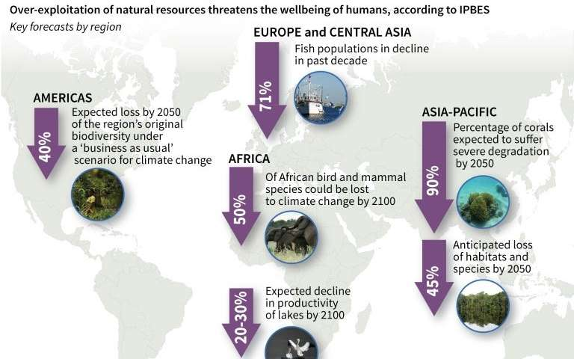](https://3c1703fe8d.site.internapcdn.net/newman/gfx/news/2018/declineofbio.jpg)**Adapted from IPBES 2018/2019

Now that you have successfully learned about water resources, answer the follwing questions.



1. Discuss the effects of mordern agricultural activities on the environment
2. Explain the effects of traditional agricultural activities on the environment
3. Discuss why many agriculture production systems are termed as a necessary evil.

|  |  |
| --- | --- |
|  | **Further reading**   1. Alon Shepon el al., (2018). "The opportunity cost of animal based diets exceeds all food losses |

**..**

**EVALUATION**

We appreciate your evaluation of the course. Please give us comments in the following areas and forward them to the Dean of the School (email) at your earliest convenience.

**Circle the most appropriate response**

Clarity of information Very clear Clear Not clear

Sequence of content Very good Good Poor

Standard of material Very good Good Poor

Questions in assessed assignment Very helpful Helpful Not helpful

Time required covering content Adequate No comment Inadequate

Suggestions you would like to make concerning this course:

-------------------------------------------------------------------------------------------------------------------------------------------------------------------------------------------------------------------------------------------------------------------------------------------------------------------------------------------------------------------------------------------------------------------------------------------------------------------------------------------------------------------------------------------------------------------------------------